**Scientific Equipment and Apparatus**

1. How is an apparatus different to equipment?
2. A student is using a Bunsen burner to heat some water in a beaker. Draw a labelled diagram of how the student should set up their equipment.
3. A student is filtering a mixture of sand and water using a filter funnel and filter paper into a conical flask. Draw a labelled diagram of their equipment.
4. In the puzzle below, there are diagrams of ten different pieces of equipment. Can you find and name them? There are no heatproof mats or watch-gasses in the picture.

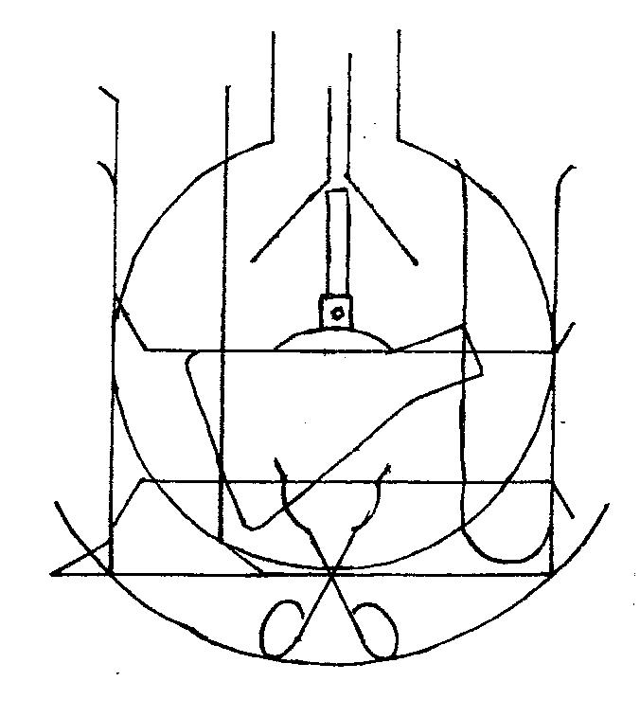

|  |  |  |  |  |  |  |  |  |  |  |  |  |  |  |
| --- | --- | --- | --- | --- | --- | --- | --- | --- | --- | --- | --- | --- | --- | --- |
| S | T | I | R | R | I | N | G | R | O | D | P | F | S | K |
| E | L | H | D | E | C | B | A | S | T | R | L | R | R | S |
| S | L | F | E | H | C | C | L | K | R | N | D | E | M | A |
| E | O | T | F | R | I | H | Y | D | E | M | C | N | I | L |
| S | R | E | T | I | M | L | D | L | H | E | K | R | C | F |
| S | L | S | O | D | R | O | U | S | I | P | L | U | C | L |
| A | P | T | S | T | N | L | M | F | U | N | E | B | F | A |
| L | L | T | R | P | O | R | K | E | G | O | D | N | O | C |
| G | A | U | Z | E | M | A | T | A | T | L | K | E | O | I |
| Y | H | B | T | G | K | D | S | F | T | E | T | S | R | N |
| T | H | E | I | A | K | A | O | C | G | D | R | N | P | O |
| E | F | G | D | S | P | O | E | W | Y | P | I | U | T | C |
| F | U | N | N | E | L | S | R | B | P | T | P | B | A | F |
| A | K | F | H | D | N | A | T | S | T | R | O | T | E | R |
| S | O | P | I | L | F | R | A | I | K | C | D | R | H | O |

1. Usually placed over a Bunsen burner (6) ________________________
2. Measuring __________ (8) ________________________
3. Eye protection (6,7) ________________________
4. Used for measuring temperature (11) ________________________
5. For scooping small amounts of chemicals (7) ________________________
6. Sits on top of tripod (5,3) ________________________
7. Can be used to heat large amounts of liquid (6) ________________________
8. Used for heating objects (6,6) ________________________
9. Cone-shaped item (7,5) ________________________
10. Helps pour liquid into containers (6) ________________________
11. Used to stir mixtures (8,3) ________________________
12. Clamps are attached to this using a boss head (6,5) ________________________
13. For heating small amounts of liquids (4,4) ________________________
14. A ___________ mat protects the bench (9) ________________________